Homework Grid – Year 5 – Autumn 2
Literacy:  Practise reading and spelling your words from the year 3 and 4 curriculum list.  Remember to read regularly at home. Try at least 3 times a week. |  | Maths:  Learn your times tables using TT Rockstars.  Practise reading and writing numbers up to 1,000,000. Can you write them in words and digits?  Login to MyMaths to complete the work set.
I am an artist:  I can design a new front cover for The Explorer. Think about using different materials e.g. paint, crayon, felt tip etc.  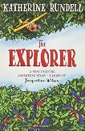 | I am a writer:  Write a poem about the Amazon Jungle and all its amazing features! Can you use a simile and personification?  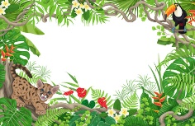 |  | I am mindful:  Record a good thing that you have done every day for a whole week! Remember to be kind to yourself as well as others.  Don’t forget to log in to Zumos and explore the chill room.
I am a linguist:  I can find out the names of my favourite foods in Spanish and learn how to pronounce them. | I am a mathematician:  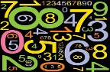  Create a matching game linked to your times tables for other people to play in school. |  | I am a designer:  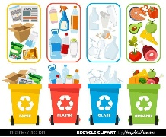  I can design and make a model using recyclable materials found in my house.

