Homework Grid – Year 6 – Autumn 2
Literacy:  Read your reading book at least three times a week.  Continue to use Reading Plus.  Practise spellings each week provided by your teacher. |  | Maths:  Practise your number bonds and times tables regularly.  Complete TT Rockstars online.  Work through the MyMaths that has been set.
I am a writer:  Write a Winter poem including exciting adjectives and verb, and present to the class. | 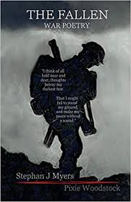  I am a poet:  Memorise a verse from a war poem and present it to the class. |  | I am a mathematician:  https://classroom.thenational.academy/lessons/linking-place-value-and-multiplication-c4vpct  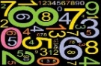  Complete the lesson online and upload any work completed on to class dojo.
I am musician:  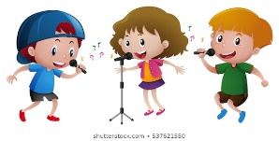  Learn and perform a traditional Christmas carol. Be as creative as you like and feel free to change the music genre (e.g. rap, classical, pop, jazz etc) | I am a global warrior:  https://worldslargestlesson.globalgoals.org/resource/introducing-explorers-for-the-global-goals/#:~:text=This%20starter%20pack%20introduces%20the,solving%2C%20creativity%20and%20effective%20communication.  Design and create a new global goals character. Think about what their main characteristics will be and how this will help achieve the global goals. |  | I am kind:  Make a little gift to give to a secret partner in the class. You can use materials from the classroom if you need to.
I am a chef:  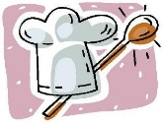  Find out about Christmas meals from around the world. Present your findings using any medium. | I am an artist:  Design a propaganda poster to encourage people to support the homeless during the winter period. |  | I am a mathematician:  https://classroom.thenational.academy/lessons/to-recognise-identify-and-describe-unit-fractions-ccwpce  Complete the lesson online and upload any work completed on to class dojo.
Please upload as much of your homework on to class dojo.

