Homework Grid – Year 3 – Autumn 2
Literacy:  Practise reading and spelling the Exception words in your reading diary.  Remember to read regularly at home. Try at least 3 times a week. |  | Maths:  Log in to your Times Table Rockstars and use the games available to practice your times tables.
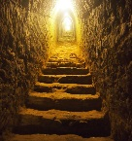  I am a writer:  Imagine you have entered the pyramids of Giza. Write what you could see and how you are feeling. | I am a mathematician:  Complete the lesson below on BBC Bitesize looking at multiplying by 1, 10 and 100.  https://www.bbc.co.uk/bitesize/topics/z36tyrd/articles/z2fkwxs |  | I am a reader:  Log on to Espresso: www.discoveryeducation.co.uk  username: student1067 password: R3idst  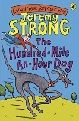  Read the extract from the The Hundred Mile-An-Hour Dog and then complete the comprehension quiz.
I am a sportsperson:  Follow the link below to complete Maui’s Shapeshifting Statues game: https://www.nhs.uk/10-minute-shake-up/shake-ups/mauis-shapeshifting-statues | 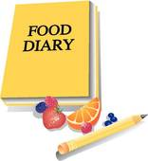  I am a scientist:  Keep a food diary of all the things you eat in a week. Can you identify which food groups your meals belong to? |  | 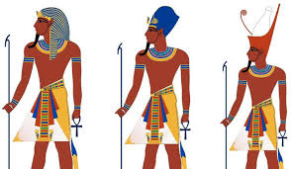  I am a historian:  Produce a word search with 6 names of pharaohs for your classmates to find. Remember to upload your word search to Class DoJo.
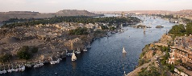  I am an artist:  Create a detailed sketch of the River Nile. | I am a chef:  Follow the link to make tasty banana ice cream. Take a picture of your delicious creation and send it to Class DoJo. 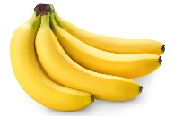 |  | I am mindful:  Find a space in your house or garden where you feel relaxed. Look for…  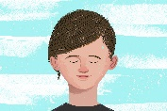  5 things you can see  4 things you can touch  3 things you can hear  2 things you can smell  1 thing you can taste  How did you feel before and after this activity?

