Homework Grid – Year 4 – Autumn 2
Literacy:  Practise reading and spelling your Exception words.  Remember to read regularly at home. Try at least 3 times a week. |  | Maths:  Use TT Rockstars regularly to practise Times Tables.  Check MyMaths regularly for up to date homework activities linked to your learning.
I am a writer:  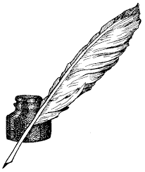  Choose your favourite book and write a detailed book review about it. | I am a geographer:  Draw a map of Italy and mark on 8 important landmarks/towns. |  | I am a linguist:  Practise your Spanish greetings including: hello, Happy Birthday and Merry Christmas.
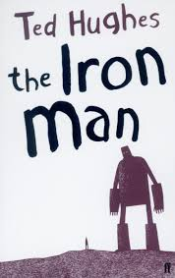  I am a good speller:  Learn to read and spell the key vocabulary linked to The Iron Man. | 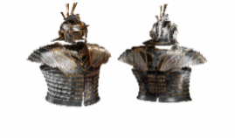  I am a designer:  Design a suit of armour for a Roman warrior and label it. |  | I am anti-bullying:  Create a cartoon strip story with an anti-bullying theme.
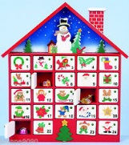  I am a designer:  Make an advent calendar to count down the days until Christmas. | I am a poet:  Select your favourite Christmas poem to recite to the class. |  | I am a mathematician:  Find out and write Roman Numerals for numbers up to 20 and then all multiples of 10 to 100.

