Homework Grid – Year 2 – Autumn 2
Literacy:  Practise reading and spelling your red words.  How many patterns can you remember? eg  If you can spell other, you can spell mother and brother.  Remember to read regularly at home. Try at least 3 times a week. |  | Maths:  Draw the tens and ones to represent different two-digit numbers.  Eg 33 = |||  If you are confident at this, try to add 2 two-digit numbers together.
I am a writer:  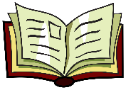  Write a set of instructions on how to make your puppet creation or how to make your favourite meal. | I am a designer:  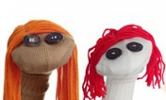  I can design and make a puppet. This could be a sock puppet. You could record a video showing your puppet and send it on Class Dojo. |  | I am a geographer:  I can find the names of the capital cities of the countries in the United Kingdom. I can find the name of the seas and oceans which surround the United Kingdom.
I am a poet:  I can learn a simple poem off by heart. You can share a video on Class Dojo.  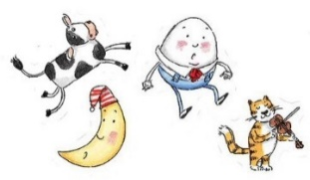 | I am mindful:  Relax with Cosmic Kids Yoga or access some videos on Zumos.  https://www.youtube.com/watch?v=LhYtcadR9nw |  | I am kind:  Look at the forty acts of kindness that is attached. How many can you achieve this week?
I am a caring person:  I can create a poster to show how to welcome a new member to the class. Remember to send a picture of your wonderful creation on Class Dojo.  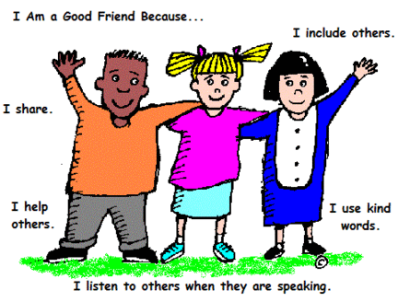 | I am an artist:  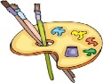  I can draw or make a scene for my puppet theatre show. |  | I am a mathematician:  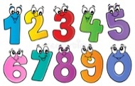  Have a go at the Oak Academy Lesson. Remember to share your score on Class Dojo.  https://classroom.thenational.academy/lessons/counting-in-twos-and-fives-chhkad
