Contents
- Page 2 – 4 Signing into Google Classroom for online learning
- Page 5 – Completing a Google Form (online quiz)
- Page 6 – Completing a Google Document
- Page 8 - Watching a pre-recorded lesson through Google Classroom
- Page 9 - Accessing a PowerPoint through Google Classroom

Signing into Google Classroom for online learning
Open Google Chrome and sign in using your pupil Gmail account.
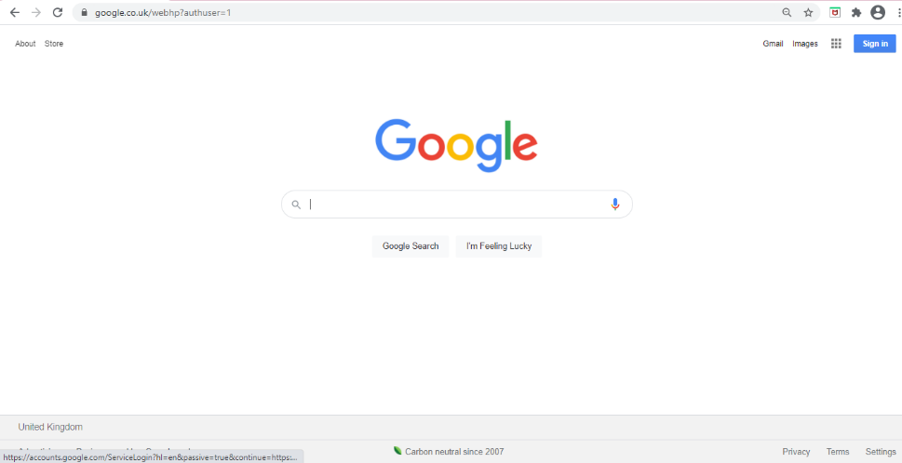
Once signed in, click on the waffle icon in the top right hand corner.
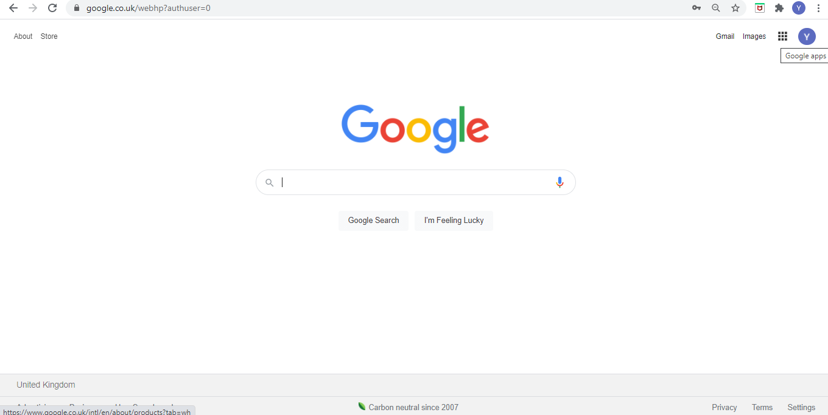

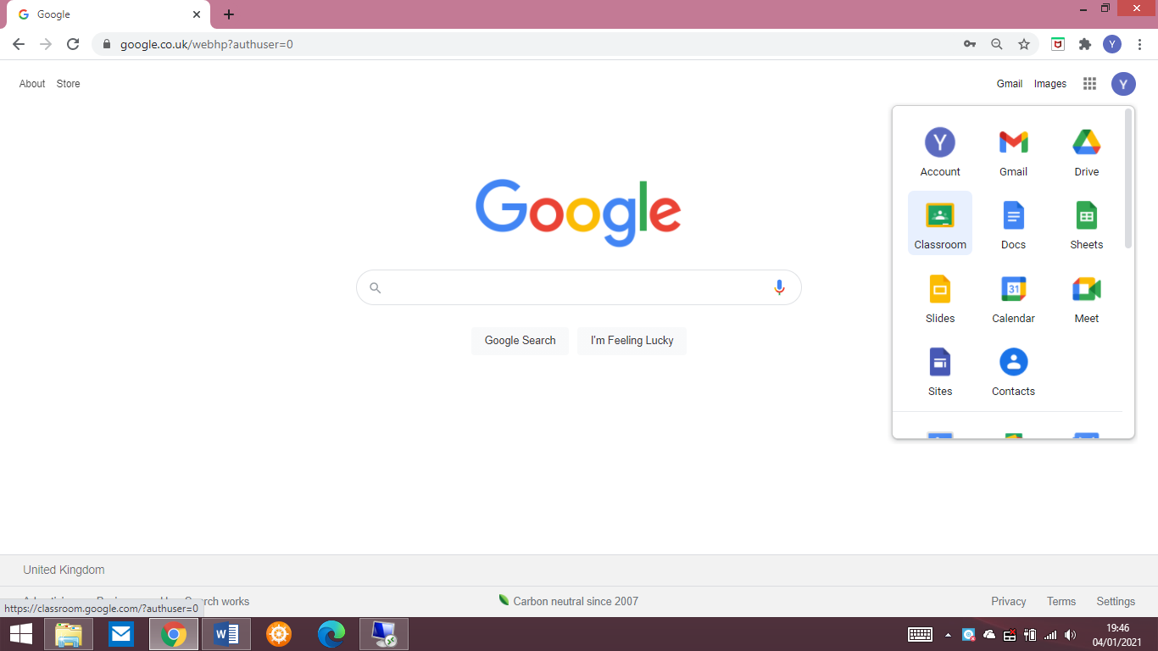
Click on the Classroom app.

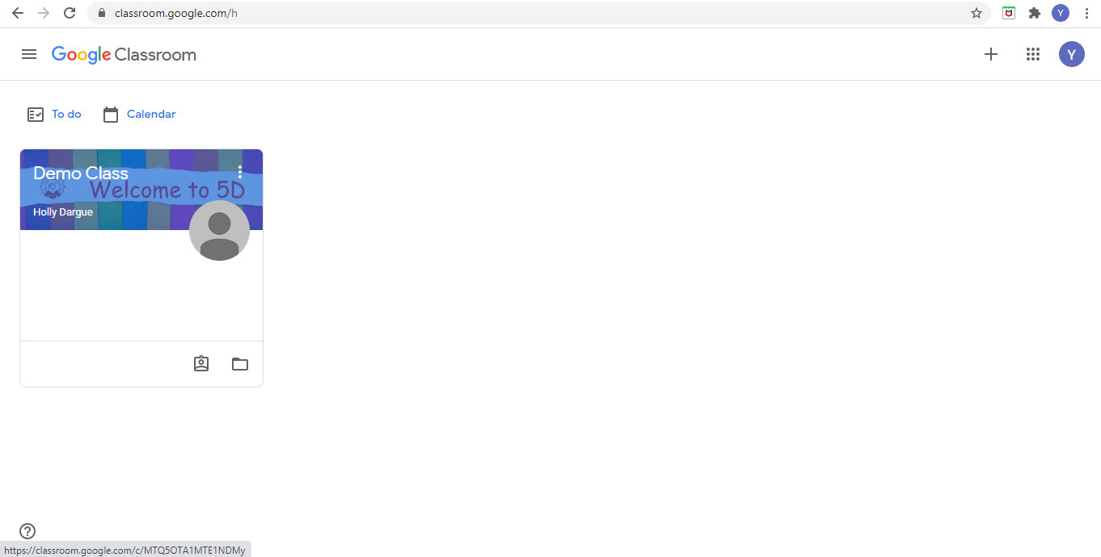
Open your classroom – you should have already accepted the invitation from your teacher to join your classroom.

Click on the ‘Classwork’ tab at the top of the Google Classroom homepage – this will be where your teacher uploads work for Literacy, Numeracy and Afternoon lessons.
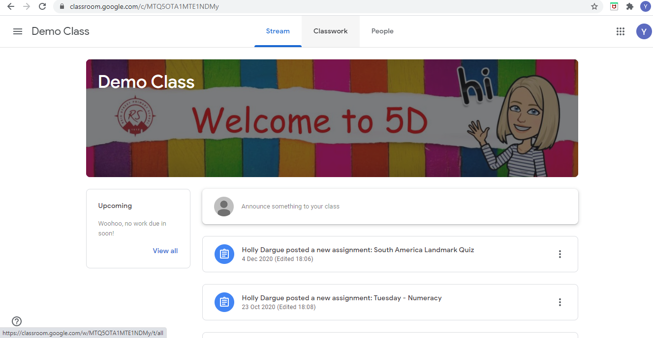

Completing a Google Form (online quiz).
The online learning set by your teacher will show what type of format it has been created in e.g. video, Google form or document. Read the instructions and click on the link. This will take you to the online Google Form.
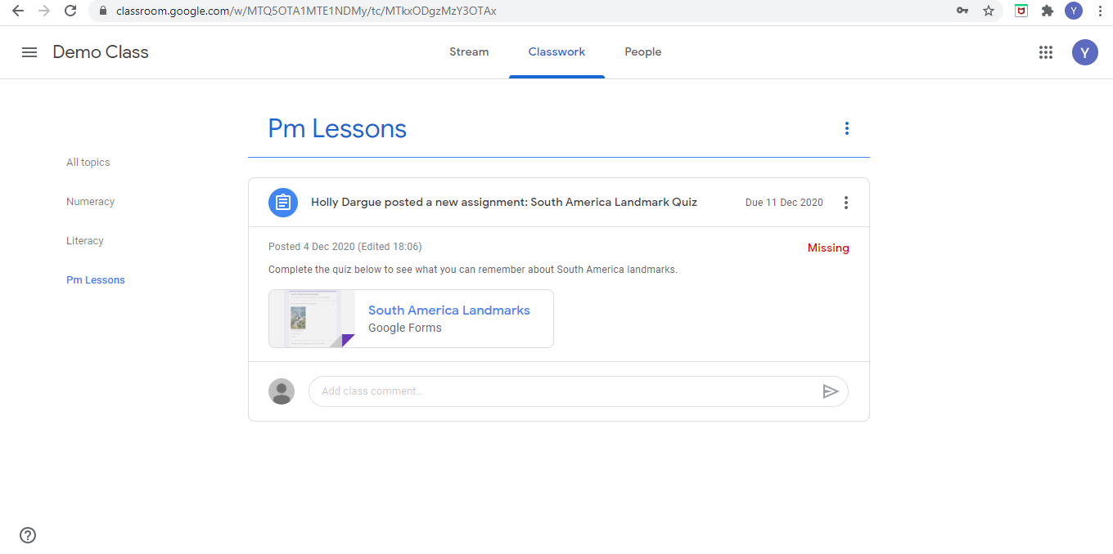
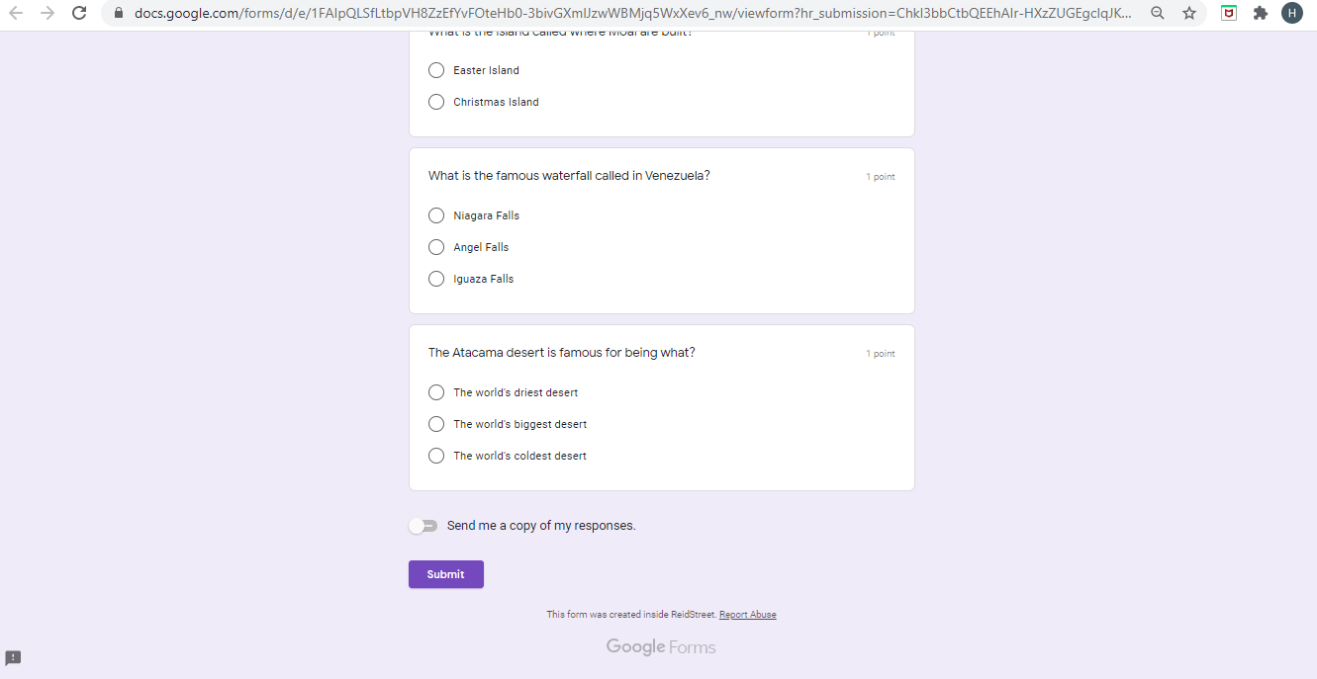
Complete the online quiz and press ‘submit’ to send your score to your teacher.

Completing a Google Document
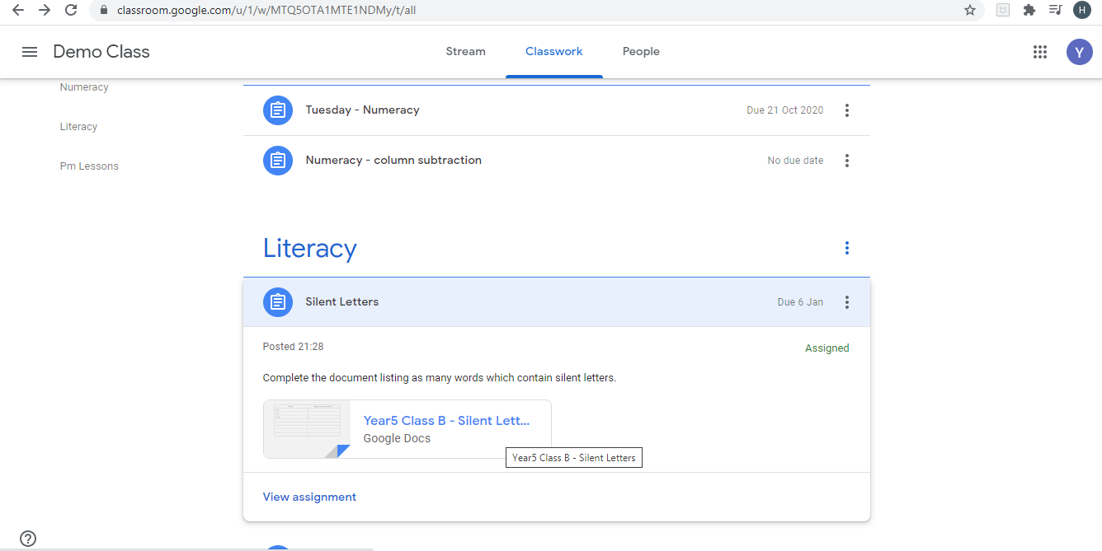
To complete an online Google document click on the link and then ‘Open with Google Docs’. You will be taken to a new tab.

Edit the document to complete the work set by your teacher – (it will automatically save itself each time you edit/add something). When completed, click the ‘Turn In’ button in the top right hand corner.
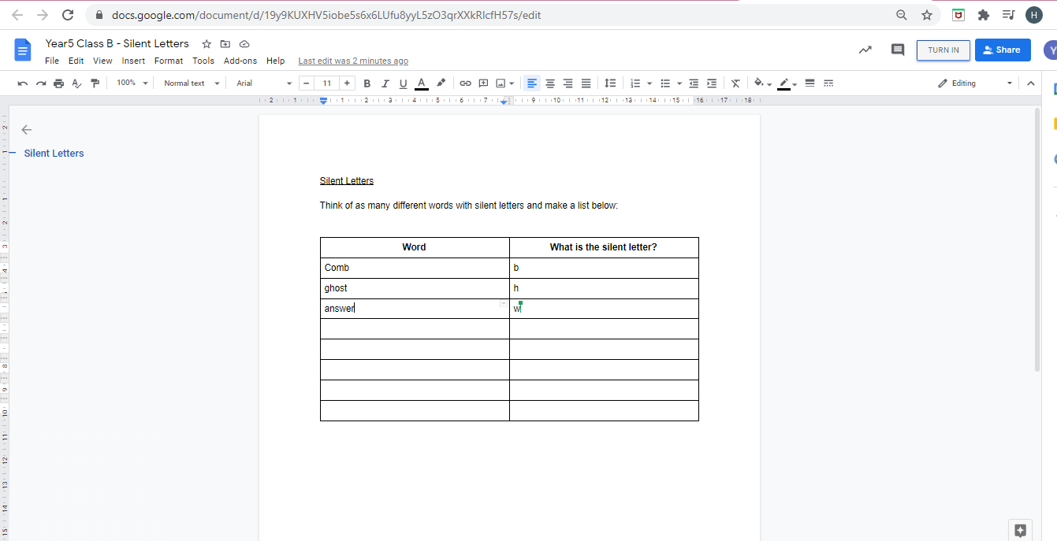
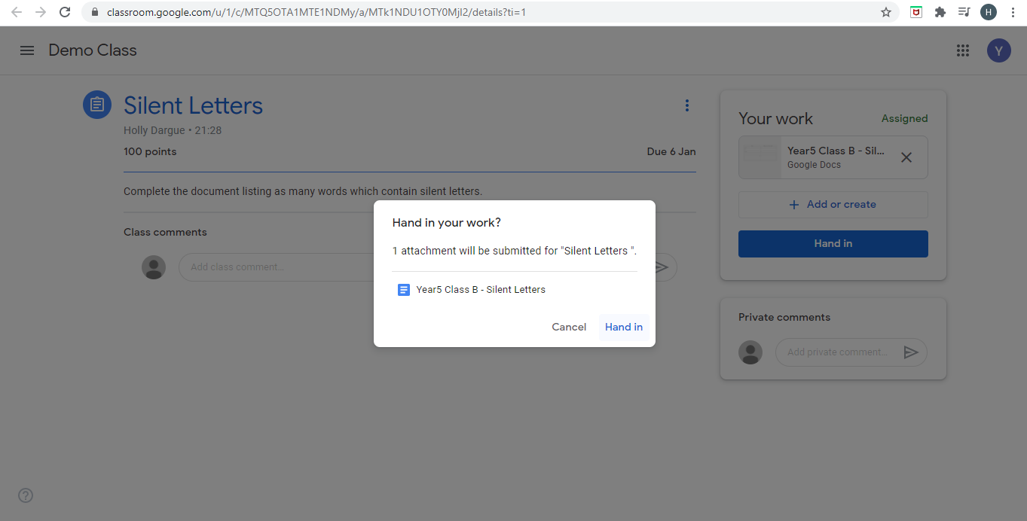
Click ‘Hand In’ to send it to your teacher.

If you want to edit the document again, you can click ‘Unsubmit’ to change your work. Remember to press ‘Submit’ again when you are ready to hand it in to your teacher.
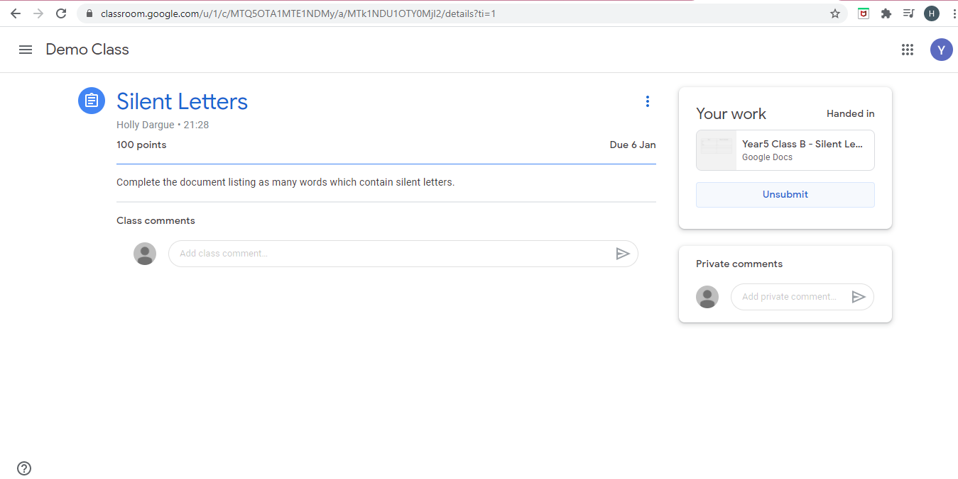

Watching a pre-recorded lesson through Google Classroom
The instructions will show that it is a pre-recorded lesson. You need to click on the link and a new tab will open to watch the video created by your teacher. This can be paused and rewound at any point. On the video, there will be instructions for how to complete and submit work to demonstrate your learning for the lesson.
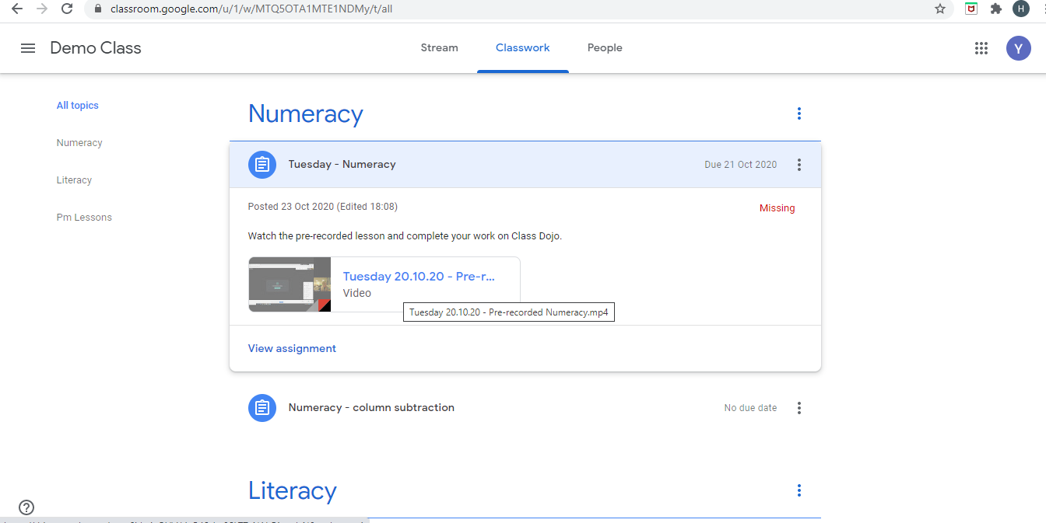

Accessing a PowerPoint through Google Classroom
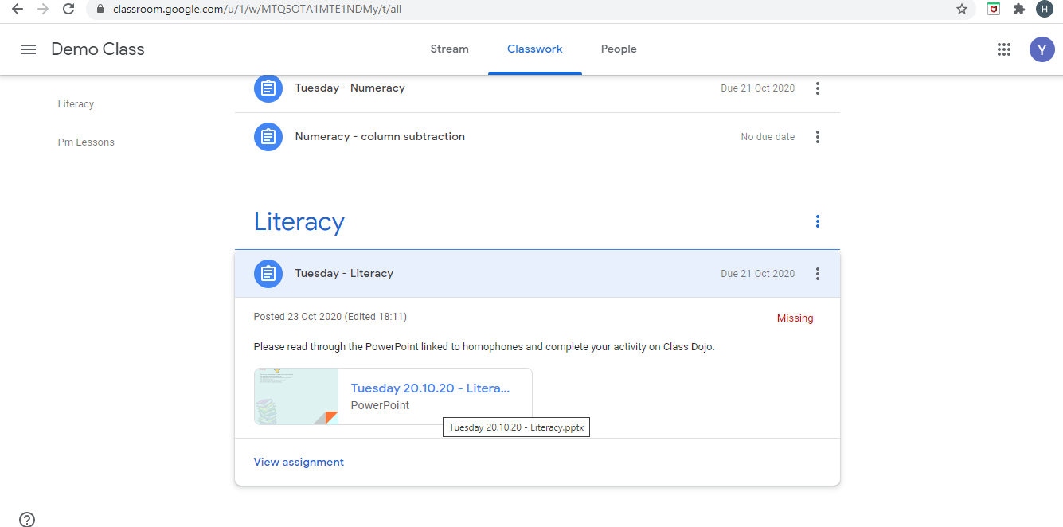
Read the instructions and click on the link to open the PowerPoint in a new tab.

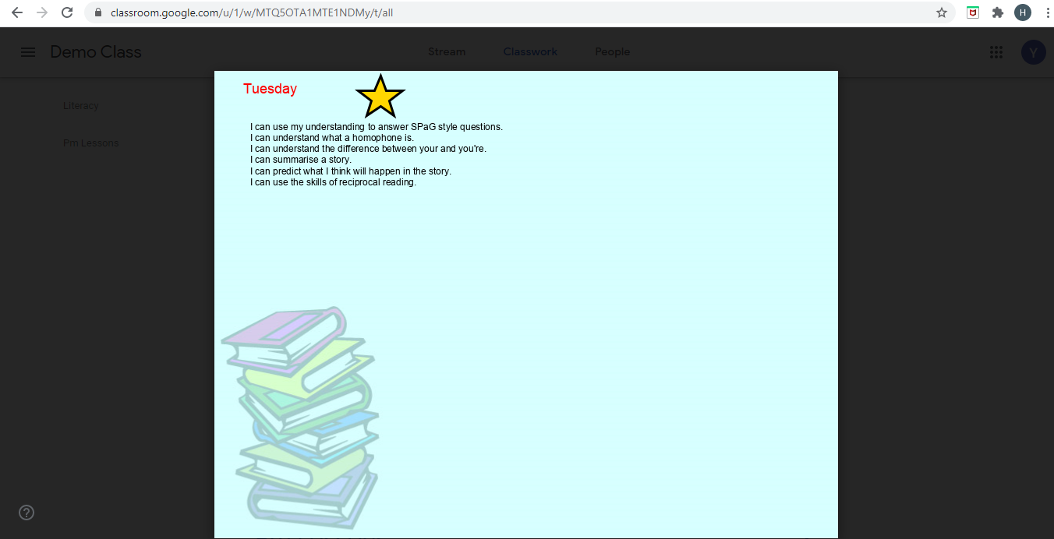
Go through the PowerPoint and complete the work set by your teacher – it will all be explained within the PowerPoint slides.

