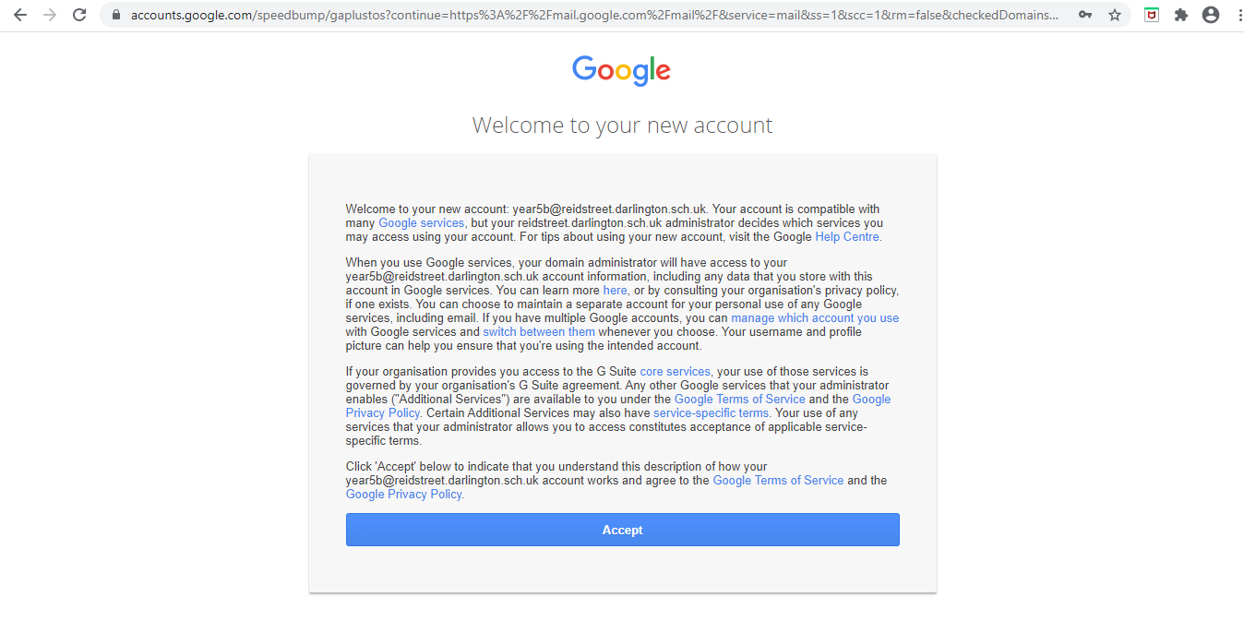
As this is your child’s first time logging in to their Gmail account, please read the terms and conditions and click ‘Accept’.

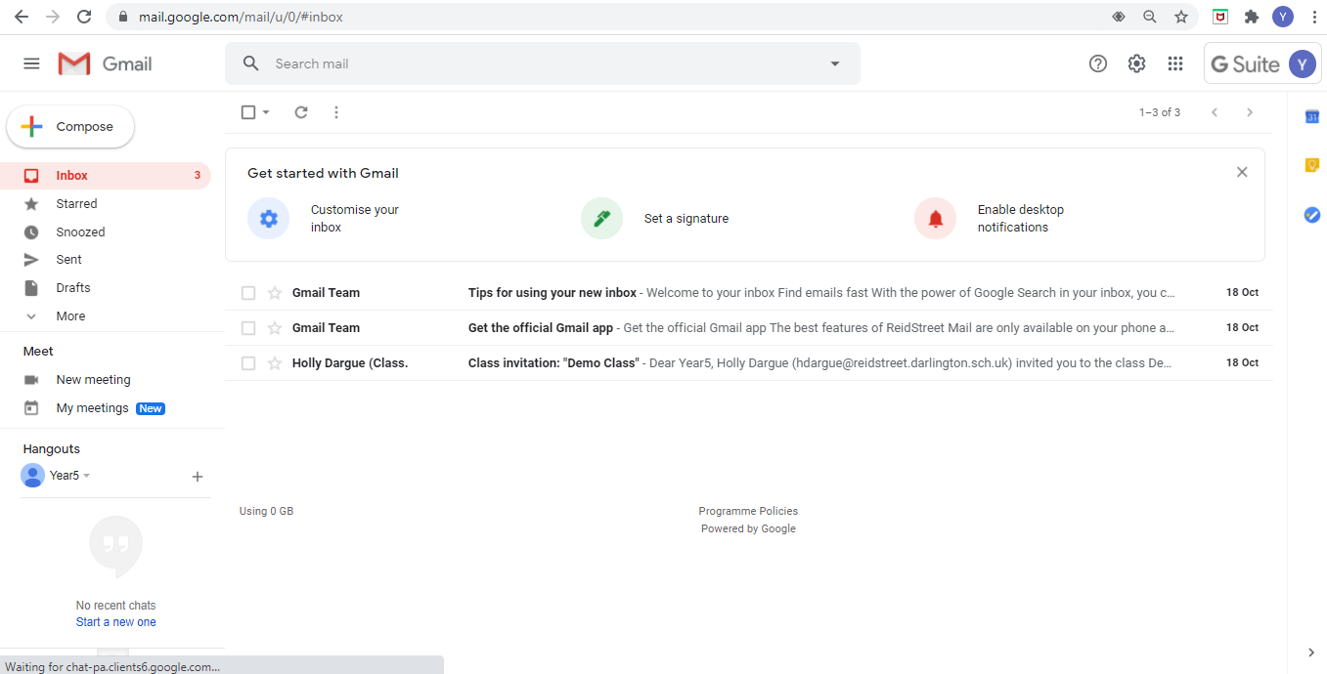
There should be an email from your child’s class teacher with an invitation to join their Google Classroom. Open the email.

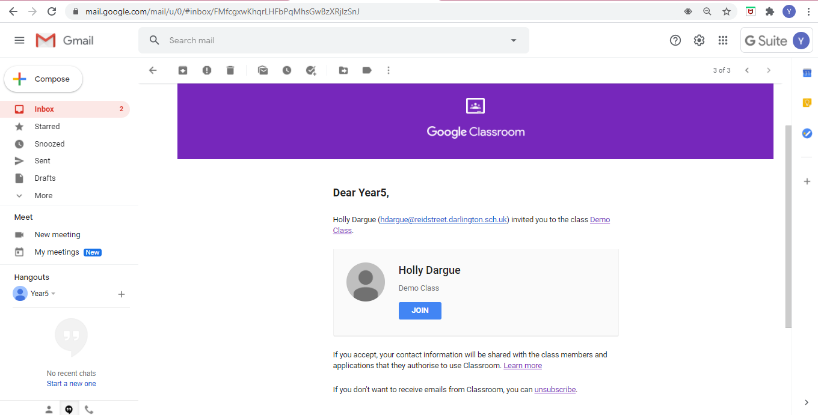
Please click ‘Join’ to accept the invitation.

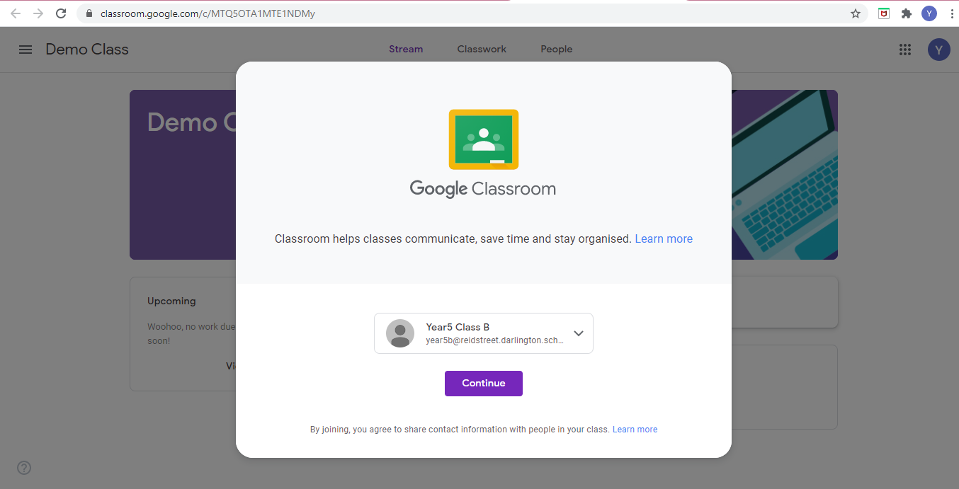
After clicking ‘Join’, you will be automatically taken to your child’s new Google Classroom. Please press ‘Continue’.

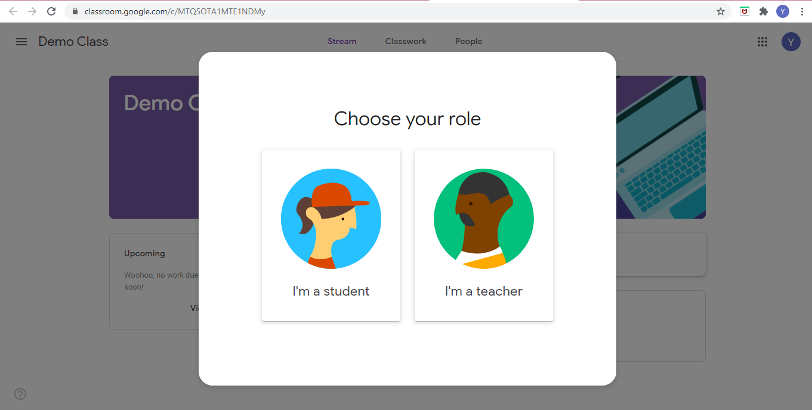
Choose the role of the child.

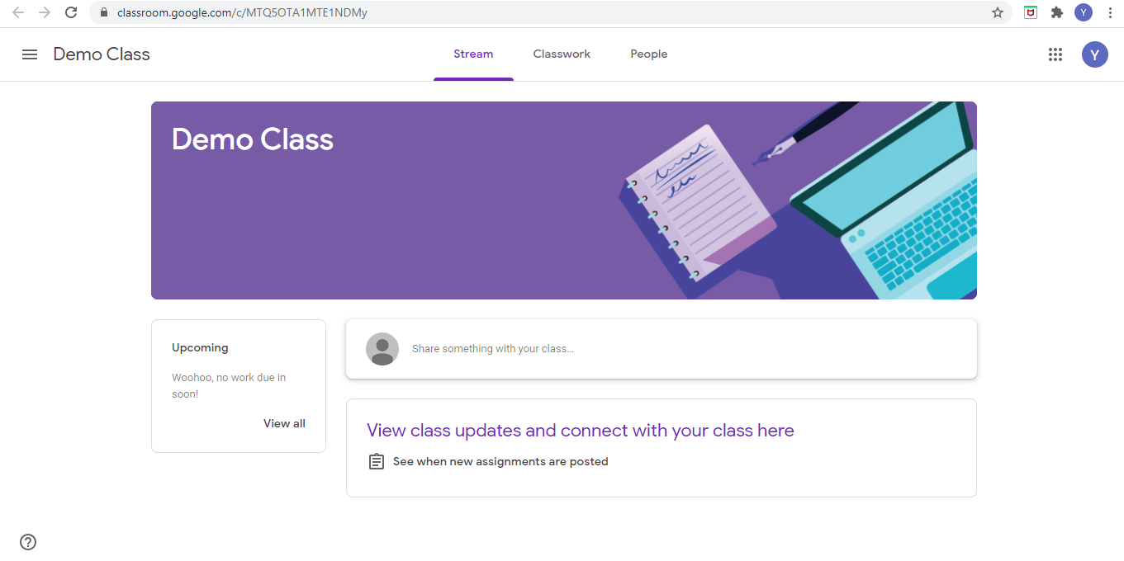
Your child will now have access to their online learning classroom. Any form of teaching will be uploaded to their Google Classroom here. You will be notified of any new lessons etc. through Class Dojo.

