Below is a guide on how to access your child’s Gmail account. There will be an invitation sent to your child’s email address to ask them to join their online Google classroom.

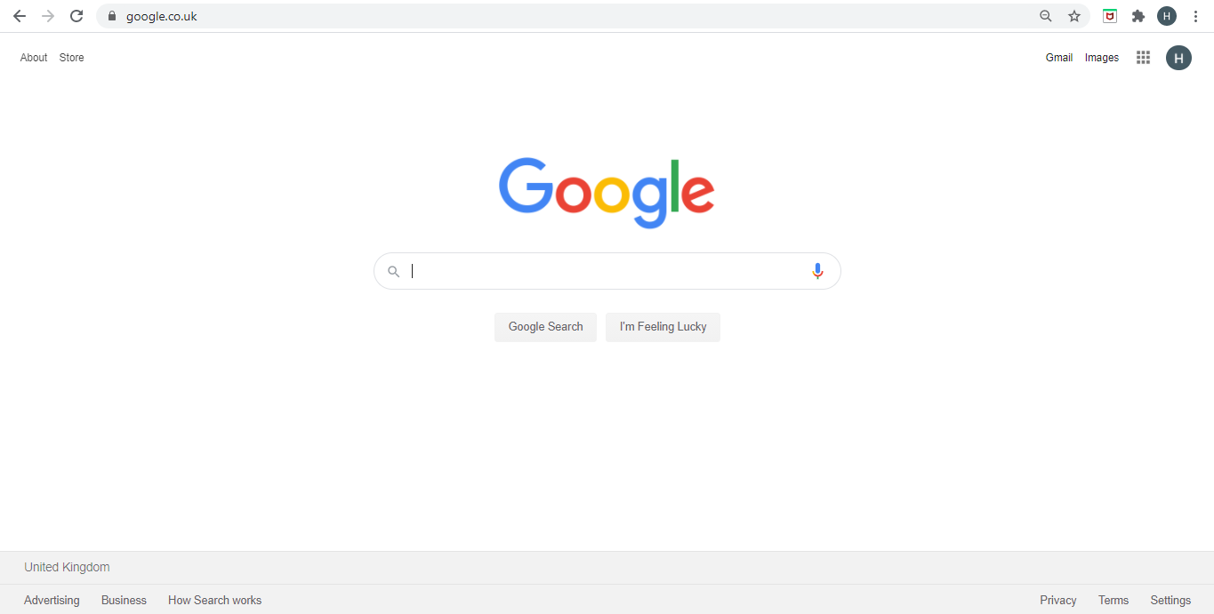
Step 1: Open up your web browser and type in Google in the address bar at the top.

Step 2: Click on the Gmail link in the top right hand corner.

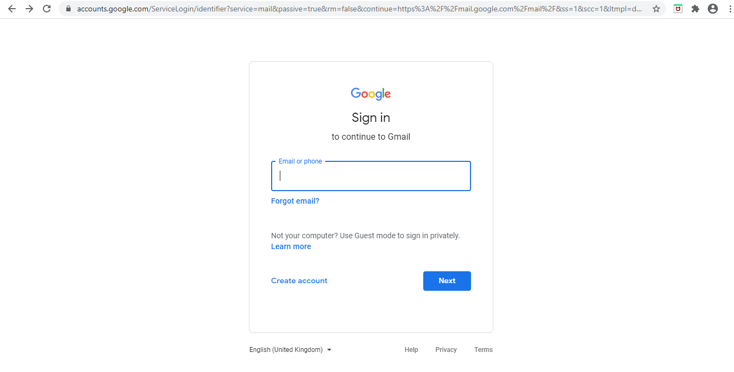
Step 3: Type in your child’s email address and click ‘Next’.
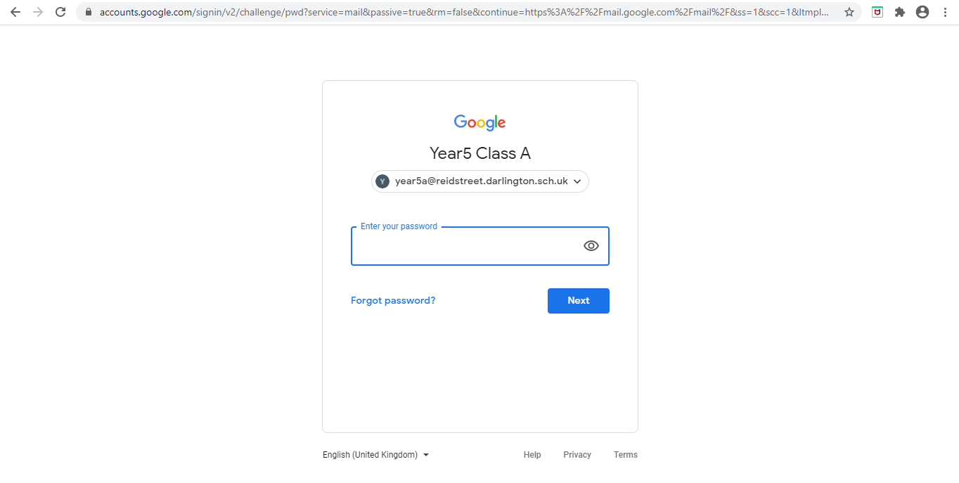
Step 4: Type in your child’s password and click ‘Next’. Your child should now be able to access their Gmail school account.

