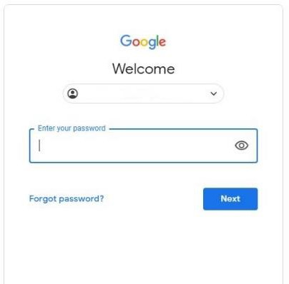
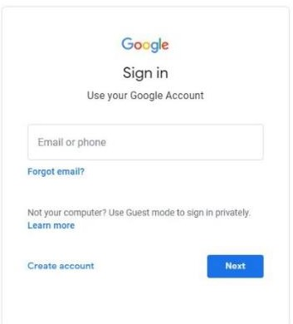
We are using Google Classroom for your child’s home learning.

Google Classroom is a space where children can access their learning online. It is available through a laptop or Chromebook as well as a downloadable app on most tablets and smartphones.

Below are instructions for how to log on and access work for your child.

Username & Passwords
Each child has a unique username and password to log on. Their username is made up of
- The first 3 letters of the first name
- The initial of their second name
- Their year of birth
- @reidstreet.darlington.sch.uk
For example for a child in year four called Jane Smith, this would be JanS2011@reidstreet.darlington.sch.uk
If you need help with this, please contact the school office.
These emails will be sent to you via Class Dojo.
Google Classroom
If accessing through a Desktop PC, Mac or laptop, this can be done by clicking on this link https://classroom.google.com or typing it into the search bar on your browser.
If you are using a Chromebook, you will need to download the Google Classroom app from the Web Store. Once done, ask your child to sign in using their school login as below. If you are unable to do this, it may be that you will need to login to the Chromebook using your child’s username and password instead from the startup screen.
If you are using an iPad or other tablet or smartphone, please download the free Google Classroom app from the App Store.

To sign in
Your child should enter their username as detailed above. This needs to be the full email address. Click next.

Now, enter their password and click ‘Next’

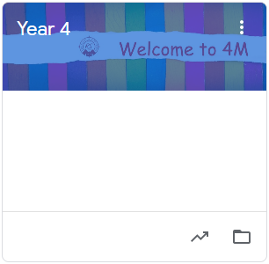
Click on the title to enter the Classroom
(the first time they log in they may need to click ‘accept’ to join the class).

You will see the following options as tabs across the top of the page:
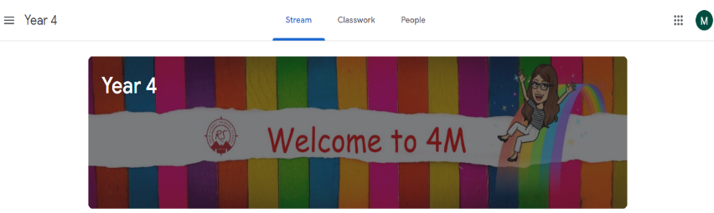

Stream
This is where your child will see posts from their teachers. Posts may contain links to websites, classwork set by your child’s
teacher or simple communications between all the members of the class. Posts are always monitored by your child’s teacher, as are any accompanying comments made by individuals, so we ask that children only use this feature if they are asking a question about their work or responding sensibly to a post.

Classwork
This is where your child will access curriculum content set by the teacher. This is the best way of accessing the content set rather than having to worry about searching on the Stream.

Any curriculum content added will be in the form of a Google Doc, Google Slide or other Google Suite app (If you are using a tablet, you may be required to download additional free apps) as this will allow the children to edit and hand in their work individually to the teacher. Classwork will be added regularly and may have a due date for completion. Teachers will be able to see your child’s progress and support them where necessary and can add comments to the children’s work.

If your child is stuck with a piece of work, they can post a comment using the private message function at the right hand side of the screen to message the teacher.

Please note that teachers are working in school with groups of children during the week so won’t be able to respond to messages every day. Year group teams will work together and may share work across more than one classroom.

